**NEURAL NETWORK DEEP LEARNING**

**ICP_4_SPRING24 ASSIGNMENT- 4**

NAME : JAYADEEP NAGUBATHULA

UCM ID: 700747518

GITHUBLINK:

<https://github.com/JayadeepNagubathula/ICP_4_SPRING24>

Video Link:

<https://github.com/JayadeepNagubathula/ICP_4_SPRING24/assets/156541783/8ad03c5c-05dc-41c2-b936-4e3c439c0543>

Data Manipulation:

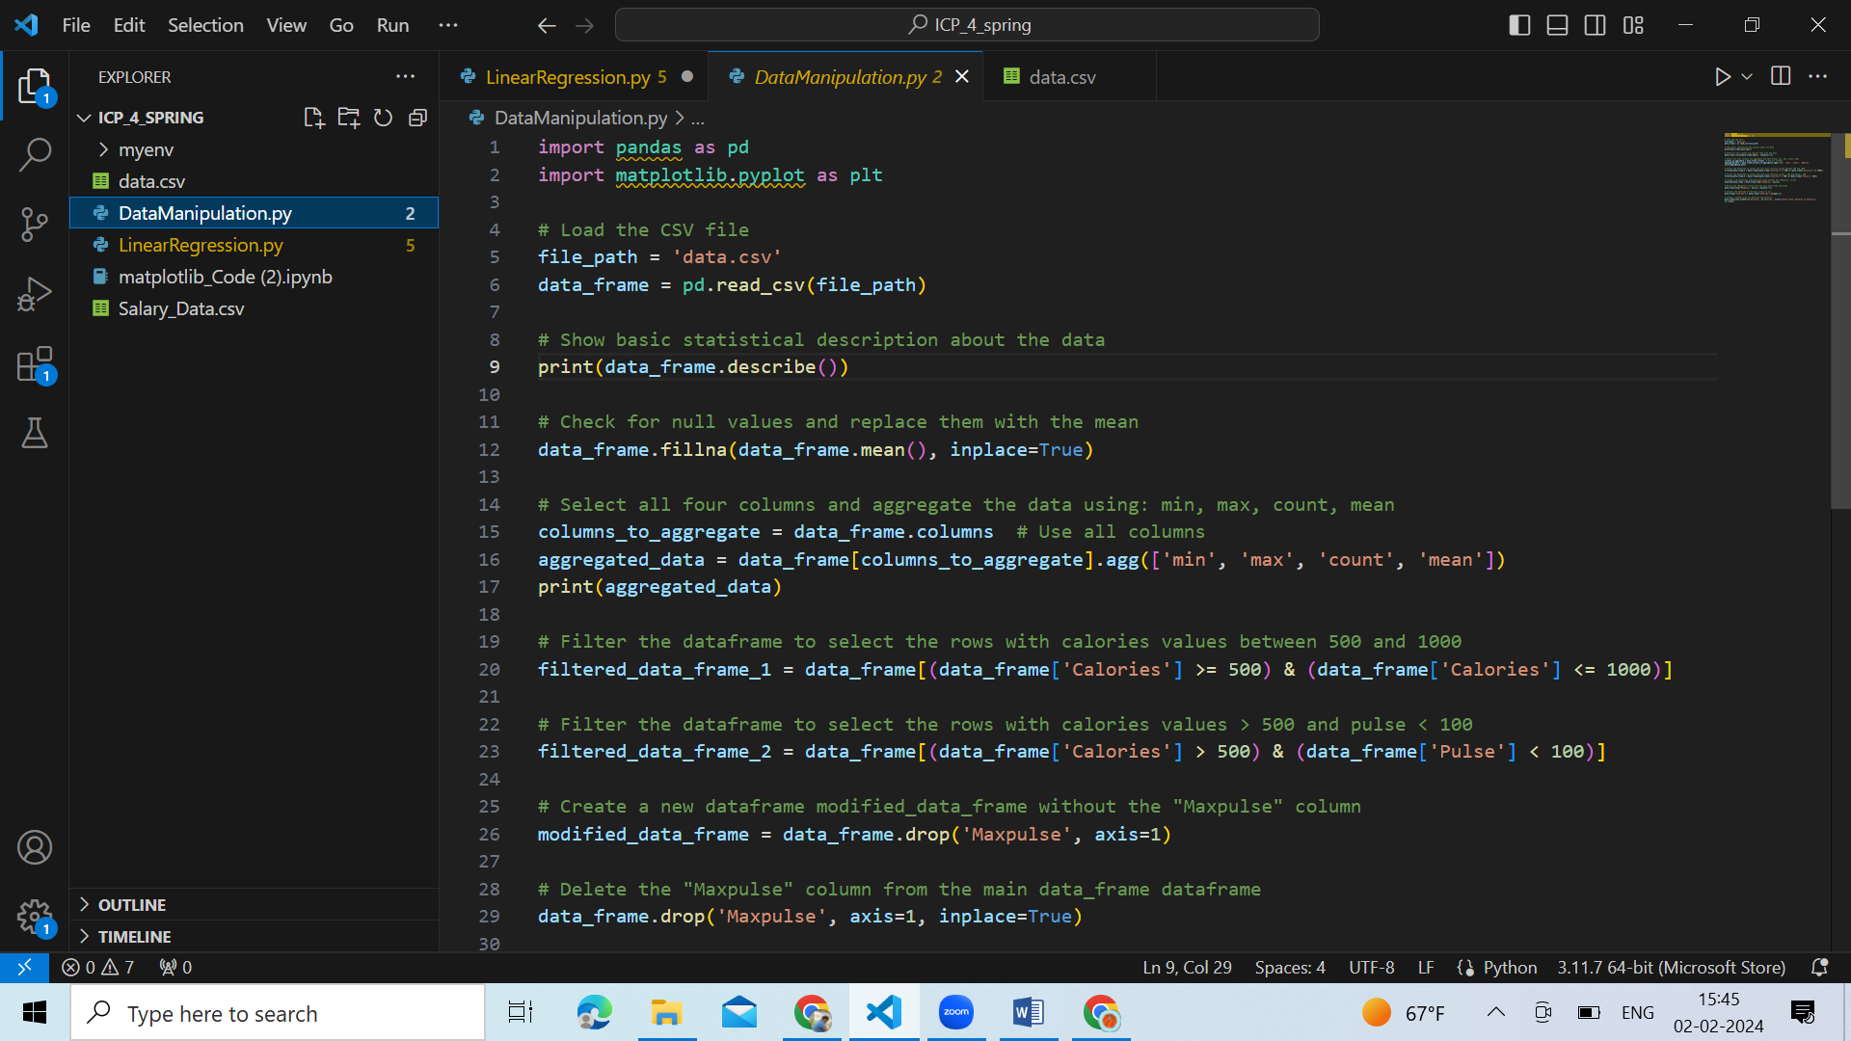

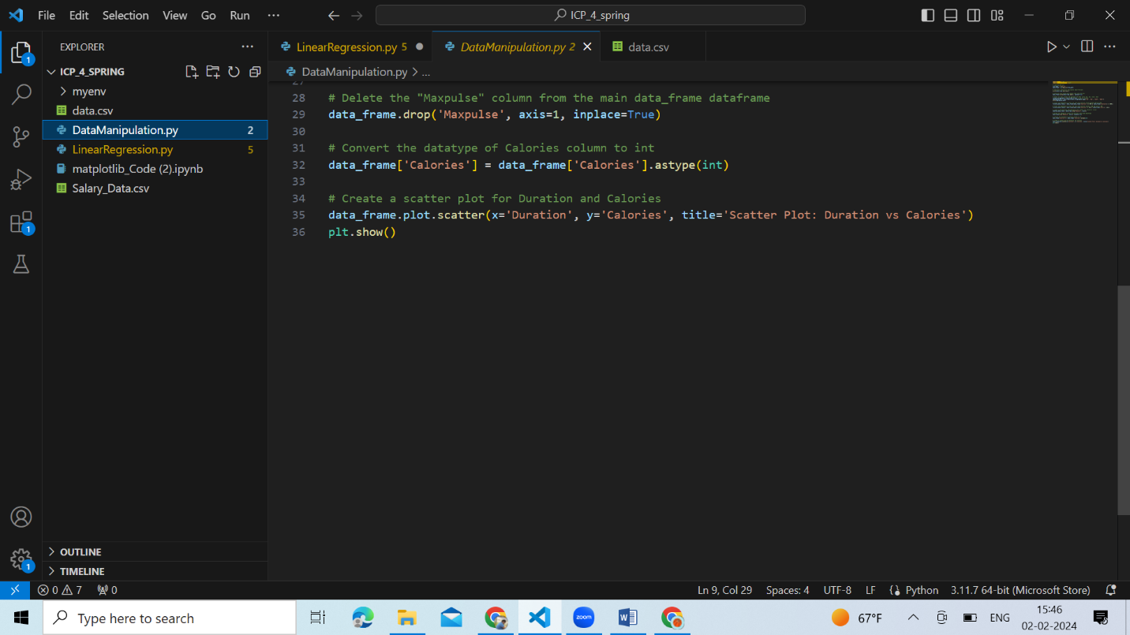

OUTPUT:

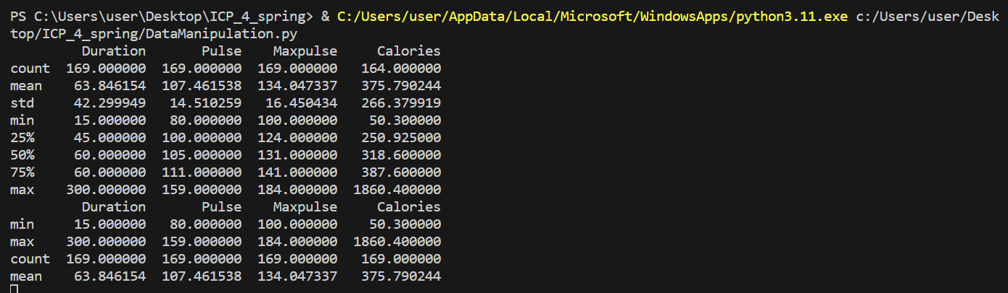

GRAPH:

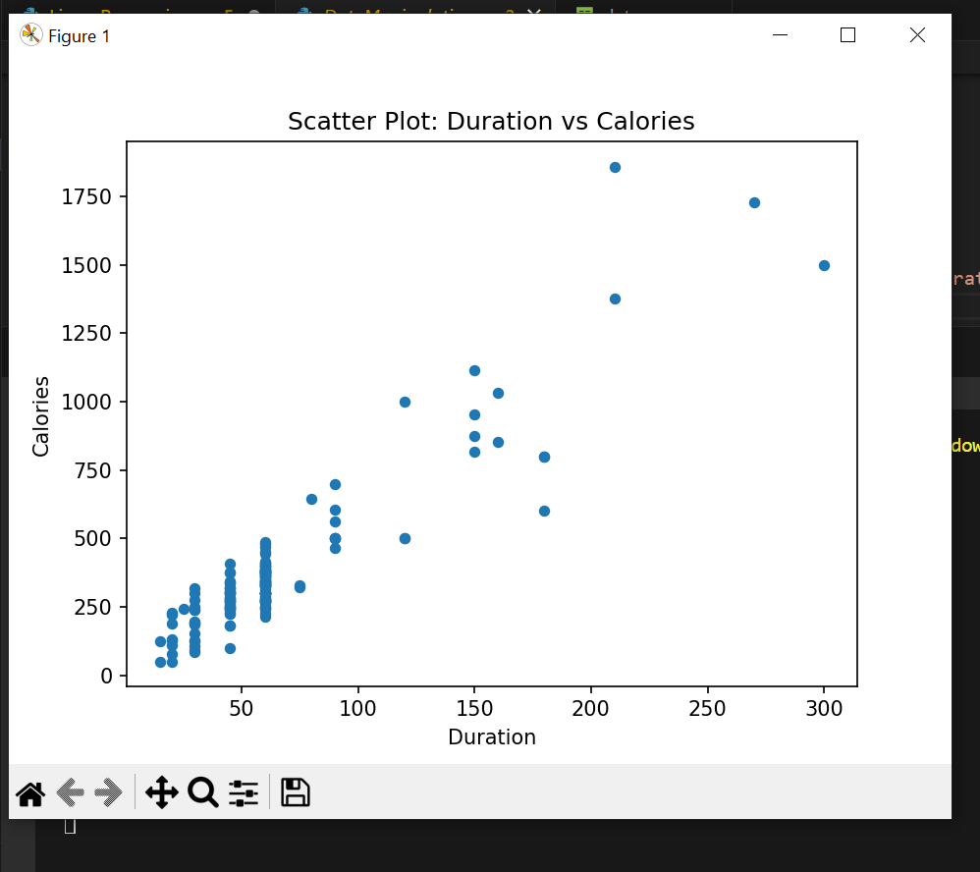

Linear Regression:

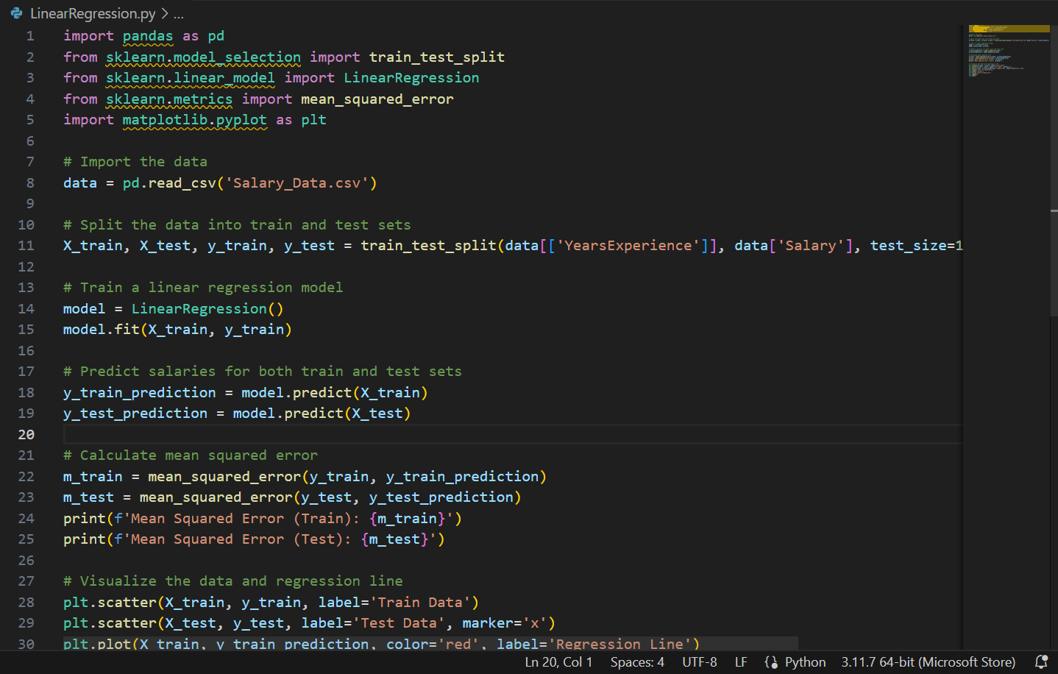

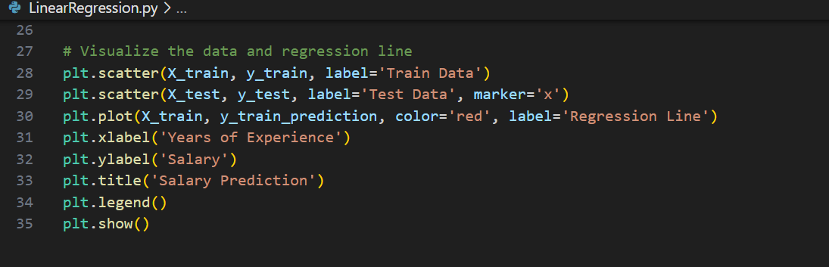

OUTPUT:



GRAPH:

